Q.1 What are Insect classes?
- Class Crustacea - lobsters, crabs, etc.
- Class Chelicerata - spiders, mites, ticks, scorpions, etc.
- Class Diplopoda - millipedes
- Class Chilopoda – centipedes
- Class Insecta - beetles, flies, moths, etc.

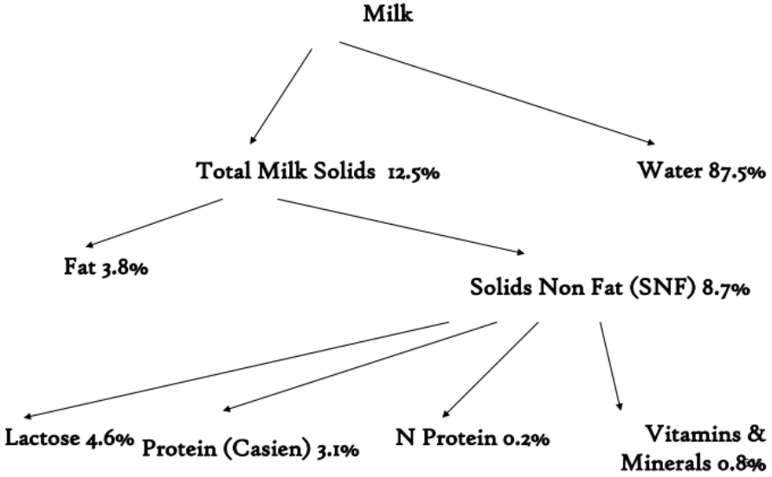
Q.2 What is composition of Milk?

Q.3 What is Skimmer?
Any species of longwinged marine birds of the genus Rhynchops, allied to the terns, but having the lower mandible compressed and much longer than the upper one. These birds fly rapidly along the surface of the water, with the lower mandible immersed, thus skimming out small fishes. The American species (R. Nigra) is common on the southern coasts of the united states. Called also scissorbill, and shearbill.

Q.4 What is Hygiene and milk quality?
Hygiene and Milk Quality
• Dirty milk (containing dirt, bacteria or antibiotics) can cause serious problems when processing.
• Dirty milk is caused by unhygienic milking machines or poor milk filters.
• Antibiotics are found in milk as residues from treatments to cows for mastitis.
• When milk is found to be not up to standard, it may be rejected by the creamery or bought at a lower price.

Q.5 What is Monogastric and polygastric digestion?
Monogastric (simple stomach)
– Pig, Dog, Human

Polygastric (ruminants)
– Cow, Sheep, Goat

Q.6 What are methods of feeding fish?
Feeding systems differ based on size of the operation.
– Small operations
– Large operations

Small Operations
– Hand feeding
• Feed is distributed by hand, shovels, or other nonautomated means.
• Most common method.
• Used for feeds not suited for automated systems.
• Meat scraps are hand fed.

Large Operations
– Automated feeding systems
• Utilize machinery to distribute the feed.
• From relatively simple to very complicated, computer-controlled.
• Blowers
• Demand feeders
• Auger feeding systems

Blowers
– Drive along the side of the pond and blow feed out into the pond.
– Attached to trucks or tractors.
– Common in levee pond and watershed pond operations.

Demand feeders
– Allow fish to bump a rod and release feed when they are hungry.
– Used in raceways.
– Fish must be trained how to use them.

Auger feeding
– Similar to systems used by swine and poultry farmers.
– Feed stored in large tanks
– Moved by augers that drop feed in pond
– Common in tanks and raceways

Q.7 Name mouthparts of house fly.
Fulcium, clypeus, rostrum, stipes, haustellum, theca, maxillary palp, labrum, prementum, labellum, pseudotrachea, furca, prestomal teeth.

Q.8 What are Second Generation and Third generation pesticides?
Second-generation pesticides
– Organic chemical (organochlorines).
– Used after WWII (presently in developing countries)
– Synthesis begins with petroleum (“oil”)
– Mechanism of actions often unknown.
– Bioaccumulation & Biomagnification.
– Toxic to animals (humans) and agricultural plants.
– Pests developed resistance.

Third-generation Pesticides
– Organophosphates and carbamates
– Less persistent in environment (good deal)
– Acutely potent nerve toxins
– More lethal in low dose than organochlorines

Q.9 What are Protein sources for fishes?
A-Animal products (fish & meat meal )
B-Agriculture by-products (algae, cereals, legumes)
C-Industrial waste products

Protein from animal
Fish meal, meat & bone meal, feather meal, by-product slaughtery (bones, organs)
Protein from plants
Soybean meal, maize meal etc.

Q.10 What are clinical sign of Bumble foot?
BUMBLE FOOT (PODODERMATITIS)
Injury to the lower surface of the foot and subsequent infection with Staphylococcus bacteria.
CLINICAL SIGNS
• Lameness
• Swelling of the foot pad
• Hard, pus‐filled abscess on foot pad

Q.11 What is treatment of bumble foot disease?
TREATMENT
• Soak foot in warm water and Epsom salts.
• disinfect with alcohol.
• If skin is open, drain pus from abscess.
• Flush abscess cavity with hydrogen peroxide to cleanout pus and debris.
• Pack the cavity with antibiotic ointment.
• wrap the foot with gauze and elastic bandage.
• Repeat daily until foot heals.

Q.12 What is Bubonic Plegue?
Bubonic Plague
• 14th Century Europe: mysterious scourge kills millions
• Centuries later it was found that rat fleas became infected with disease-causing bacteria
• Fleas sought other warm-blooded hosts (humans) when rat numbers declined
• Plague is currently managed monitoring for plague and reducing the number of rodent hosts for fleas.

Q.13 Name vector born diseases?
Typhus
– 1996 Burundi 24K cases
– 1945-6 Japan and Korea 30K cases
– Historical outbreaks with millions
Scrub typhus
– Up to 20% of fever
Chagas’ Disease
– 18M cases of 100M in endemic areas
– Incurable chronic form
Dengue
– 2000 cases/100K, reported cases lower
– 4 x increase 1975-1995
Leishmaniasis
– 57 cases/100K (350M at risk)
Lyme disease
– 31.6 cases/100K in 10 states
WNV in US
– 0.33 cases/100K in 2003

Q.14 What is Natural pest control?
Natural Pest Controls
- Wind
- Temperature
- Humidity, rain
- Rivers, lakes, mountains
- Pathogens, predators
- Food supply of the pest
- Cultural control
- Control by natural enemies
- Genetic control
- Natural chemical control

Q.15 What are Pathway of biological pathogens?
Types of pathogen transmission:
• Mechanical
• Biological
Biological:
• propagative
• cyclopropagative
• cyclodevelopmental

Pathways of biological pathogen transmission:
Vertical transmission:
• transovarial transmission
Horizontal transmission:
• Venereal transmission
• transstadial transmission

Q.16 Write composition of Lac.
Composition of Lac:
• Lac is a mixture of several substances, of which resin is the main constituent. The approximate percentage of different constituents of lac is given below:
• Resin – 68 to 90%
• Dye – 2 to 10%
• Wax – 5 to 6%
• Mineral matter – 3 to 7%
• Albuminous matter – 5 to 10%
• Water – 2 to 3%

Q.16 Explain Life cycle of insects.
There are two different types of insect life cycle - incomplete metamorphosis and complete metamorphosis. (Metamorphosis means a change of form.)

(Define metamorphosis by yourself)

Q.17 What is fungus?
What is a fungus?
• Fungus are multi-cellular, spore producing organisms that live off other organisms, and dead matter, some are parasitic.
• Fungal spores are commonly found in aquarium water.
• Healthy fish have protective mucus covering which can prevent infection by fungal spores.

Fish fungus
Cause
• Aquatic fungi e.g. Saprolegnia.
• Fish that are in poor health and have damaged mucus membranes through bad water quality, rough handling, fighting or physical injury are more prone to infection. Fungus can be a secondary infection to other conditions.

Symptoms
• Grey white or brown cotton wool like growths on the skin or fins.

Treatment
• Medicines containing malachite green can be used and salt baths help recovery.

Q.18 What are catageries of plant pathogens?
Plant Diseases
• Pathogens
– Living agents
– Fungi
– Bacteria
– Viruses
– Nematodes
– Phytoplasmas

Q.19 How do you recognize that fish become ill?
• Colour may fade out / change
• Body shape, condition and / or behaviour will be abnormal
• The fish may refuse to feed or overfeed and trailing faeces appear at vent.
• Condition of the fins and gills will deteriorate.
• Fins may be clamped close to body.
• The fish may not keep its swimming position.
• There may be signs of injuries, outgrowths or abnormalities.

Q.20 How many exposure does it take to make your population resistant?
How many exposures does it take to make your population resistant?
• Expose a population to a pesticide several times with mating in between exposures and see how many exposures it
takes for resistant bugs to become the majority.
• Rules of the Game:
– Toss your population (pennies) on the ground, and consider all with painted sides showing as exposed to
pesticide
– All exposed yellow (RR = susceptible) die so remove these pennies.
– All exposed red (rr = resistant) survive and double; add a red penny for each exposed red penny.
– For every three exposed blue (mild resistance) add one of each color. (Keep track of any remaining blues
(<3) to ad to those on the next throw)
– Keep track of the exposure count and repeat until most pennies are red.

Q.21 Write sources of protein.
Sources of Protein
6 common sources
1. Soybean Meal
2. Cotton Seed Meal
3. Fish Meal
4. Tankage
5. Skim Milk
6. Alfalfa
- Protein is the most common Nutrient Deficiency

Q.22 What are component of IPM?

1. Identify and Understand
• Is it a pest, beneficial, or just there?
• Study pest biology
– Pest classification
– Life cycle
– Over-wintering stage
– Damage impacts
– Environmental needs
– Vulnerable control stages/timing
• Key pests
– Prior knowledge of which common pests may pose a problem
– Recognition of damage symptoms
– Recognition of diseases
– Recognition of beneficial insects
– Frequent monitoring
• Occasional pests may become troublesome from time to time
• Secondary pests become problems when key pests are controlled or eliminated
– such as spider mites

2. Monitor the Pest
• Use scouting, trapping, weather data, models
• Economics or aesthetics trigger need for action
– Pest population
– Beneficial population
– Geographic location
– Plant variety
– Plant type & stage of growth
– Cost of control measure(s)
– Value of plant or crop
• Action threshold: unacceptable pest level
– do something
• Sometimes the action threshold may be zero!
• Action thresholds vary by pest, site, and season

Treatment or Action Threshold
• Economic Threshold
– pest population density when control is necessary to prevent economic injury
• Economic Injury Level
– when the cost of losses equals the cost of control measures
– Apply control measure prior to reaching economic injury level

3. Develop the IPM Goal
Prevention: weed-free seed, resistant plants, sanitation, exclusion, pesticide treatments
• Suppression=reduction cultivation, biological control, pesticides
• Eradication=elimination small, confined areas, or government programs

4. Implement the IPM Program
• Make sure you have taken initial steps
– Identification and monitoring
– Set action thresholds
– Know what control strategies will work
• Select effective and least harmful methods!
• Observe all local, state, federal regulations!

5. Record and Evaluate Results
• Know what worked and what did not
• Some aspects may be slow to yield results
• Might be ineffective or damaging to the target crop, beneficial insects, etc.
• Use gained knowledge in future planning efforts

Q.23 What are tips for beepkeers?
- There is only one correct way to smoke, but no two beekeepers agree what that is! My smoker is filled with pine straw. Smoke makes the bees unusually calm.
- Remove a super full of honey and get rid of the bees. I use a leaf blower without the snout. You can use a fume board and Bee-Gone but I do not use chemicals. Blow the bees out of the super in front of the hive, it’s like taking them to Six Flags!
- Supers full of honey are heavy, shallow 37 pounds, medium 52 pounds and a deep 90 pounds so you need a device to carry from bee yard to honey house.
- You need a honey house (a place where the bees cannot get into), a decapping tank (holds wax and a little bit of honey that dripped off the open frames).
- Honey on a frame is somewhat like a bottle of soda, you can’t taste it until it is open. Here we are using a decapping knife (gets hot like your mother’s iron and has sharp edges on both sides).
- Sometime the bees do not build out the comb to where the decapping knife can cut it so we have to pick or scratch the capped comb open.
- We must get the honey out of the frames of comb and we do this with the aid of an extractor. Years ago beekeepers would squeeze it out by hand.
- When the extractor gets full you need a bucket or buckets to store the honey in. This is also a good time to filter the honey and I use panty hose stretched across the top of the five gallon storage bucket.
- Here the finished product is a quart of honey. I usually let my honey sit for a few days so any particles that the panty hose did not filter out will rise to the top.

Q.24 What are safety precautions for working around honey bee colony?
– A hat or veil is commonly used to keep the face and neck protected from stings.
– Gloves are another popular form of beekeeping protection, although many beekeepers complain that gloves restrict their movement.
– A hooded suit, typically made from a light colored fabric to help distinguish the beekeeper from the honey bees natural predators, may also be used.

Q.25 What is swarming?
Larvae begin to wander in search of suitable center to fix them. This mass movement of larvae from female cell to the new off-shoots of host plant is termed as “swarming”. Swarming occurs after the emergence of nymph and it may continue for 5 weeks.

Q.26 How we apply IPM?
1. Identify the pest and know its biology
2. Monitor and survey for pests
3. Set IPM goal: prevent, suppress, eradicate
4. Implement
1. Select control strategies
2. Timing
3. Economics
4. Environmental impacts
5. Regulatory restrictions
5. Evaluate

Q.27 Differentiate between Autogeny and Antogeny.
In entomology, anautogeny is a reproductive strategy in which an adult female insect must eat a particular sort of meal before laying eggs in order for her eggs to mature. This behavior is most common among dipteran insects, such as mosquitoes.

Autogeny is a hypothetical organic phenomenon by which living organisms are created from nonliving matter. synonyms: abiogenesis, autogenesis, spontaneous generation.

